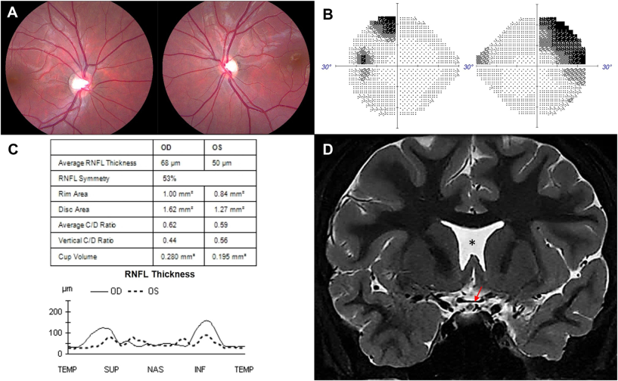

A 13-year-old girl was referred for suspicion of glaucoma. Examination revealed extensive horizontal cupping of the right optic disc andmild hypoplasia of both optic nerves (A) with otherwise normal color vision, intraocular pressures, and neuro-ophthalmic examination.Humphrey visual fields showed bilateral superotemporal defects respecting the midline (B). OCT confirmed optic nerve hypoplasia, moresevere in the left eye, with thinning of the nasal and temporal retinal nerve fiber layer (RNFL) bilaterally (C). Magnetic resonance imagingshowed chiasmal hypoplasia, more severe on the left side (red arrow), and an absent septum pellucidum (asterisk) (D). Based on the provided images and clinical description please make an ophthalmic diagnosis for this patient. And output the diagnostic conclusions only.

**Septo-optic dysplasia**